Steps for Cloning remote repository and bringing down asset(s):

1. Obtain the url for the repository you want to clone

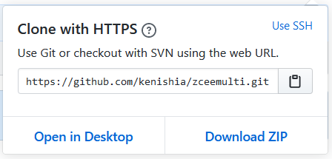

1. In toolkit go to Git Perspective and right click in open space and choose Clone a Git repository

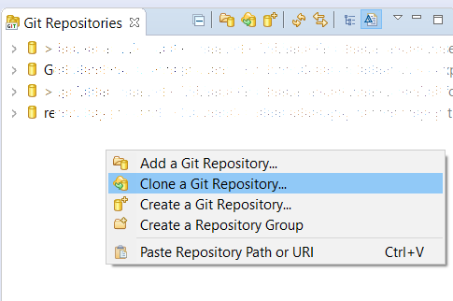

1. Paste the uri in the pop up window

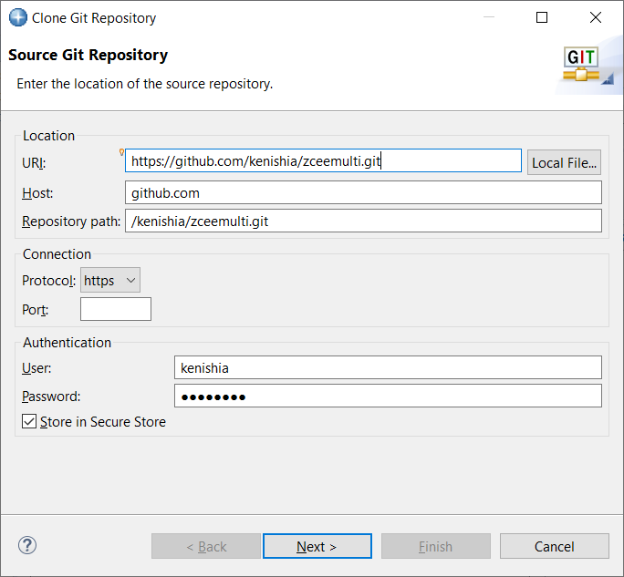

1. Click Next
2. Choose your Branch and click Next

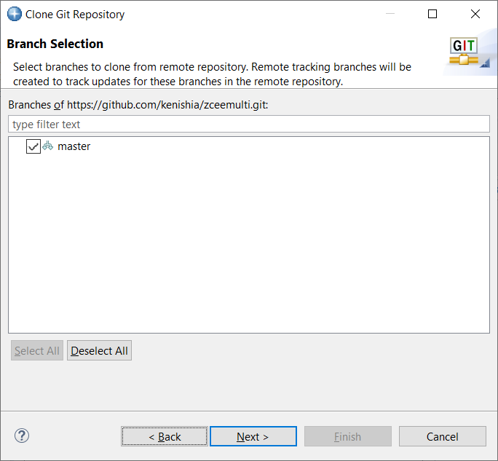

1. Choose options you feel most appropriate and click Finish

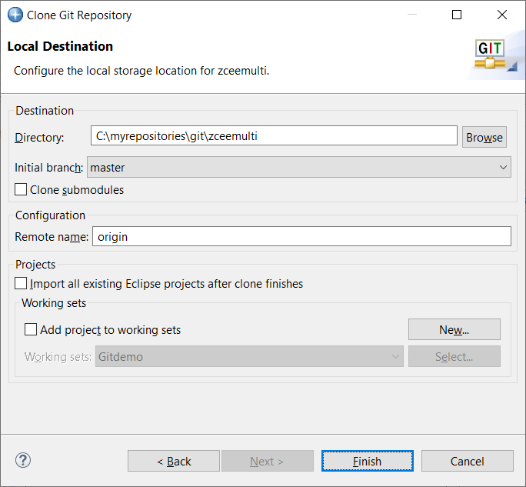

1. If you did not choose “Import all existing Eclipse projects after clone finishes”
2. Click on the twisty next to the repository that was just added

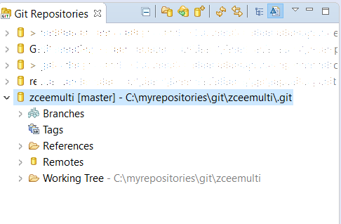

1. Click on the twisty next to Working Tree
2. There, you will see the projects available for import

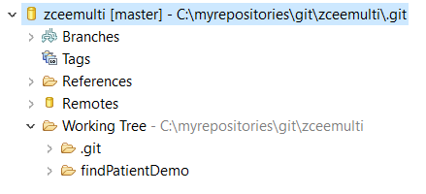

1. If you are importing a project folder, right click on the project you would like to import and choose Import Projects. *If you are importing a .zip file, go to step 13.*

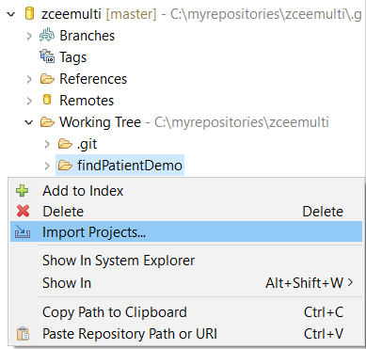

1. At the pop-up window, choose to add to a working set or just click “Finish”. ***Then skip to step 17***

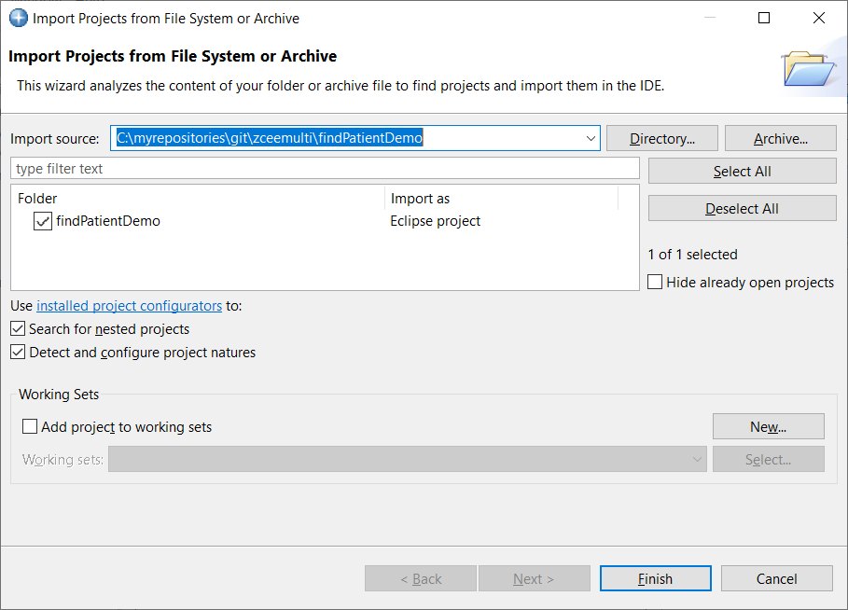

1. If the project is in .zip format, then right click on the working tree and choose Import Projects

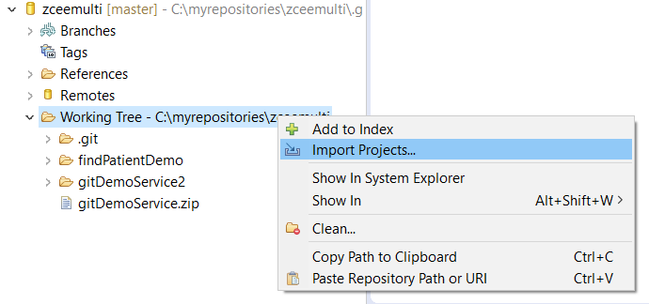

1. Click Archive

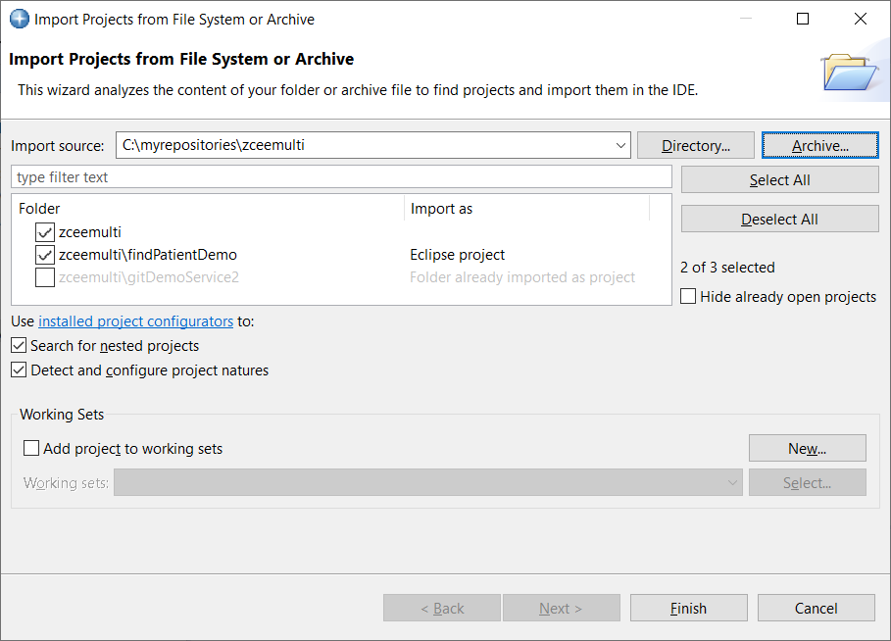

1. Choose the .zip file you want to import

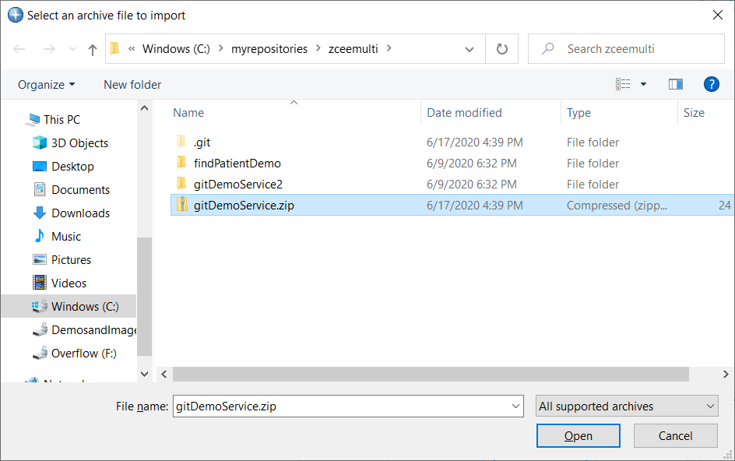

1. Choose the folder with the words Eclipse Project next to it, then optionally choose to add to a working set and click “Finish”

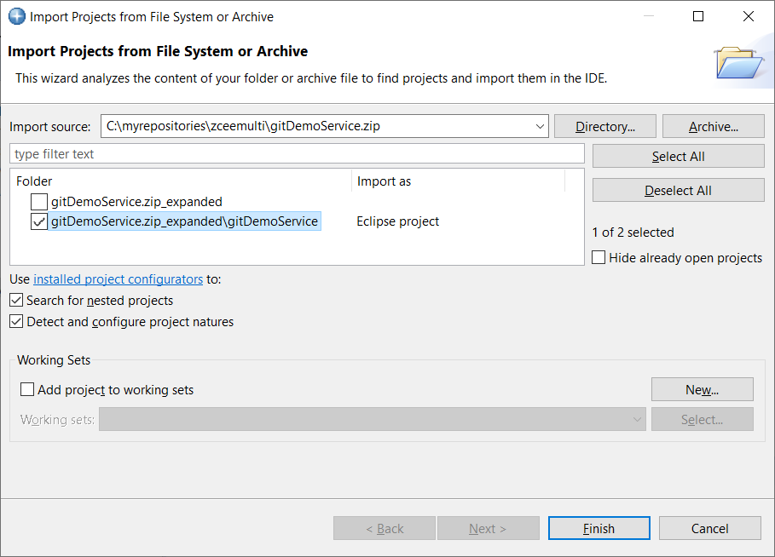

1. Switch to z/OS Connect EE Perspective in Explorer

(Window -> Perspective -> Open Perspective -> Other -> z/OS Connect Enterprise Edition)

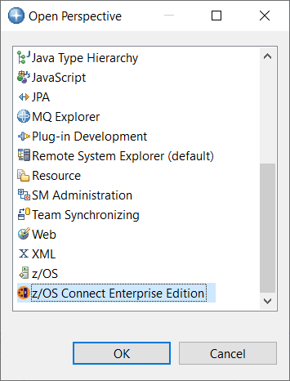

1. The project will now be in the Project Explorer section of this perspective

